Assignment 2
Advance HPC Lab
PRATIK ABHANG | 260740150018
AKANKSHA JADHAO | 260740150004

Part A — MPI message passing

1. Aim
To demonstrate communication between MPI processes: process 0 sends a message, and the other processes receive and display it.

2. Program used
Source file: basic_mpi.c

3. Step-by-step procedure
- Include mpi.h for MPI functions and stdio.h/string.h for printing and string operations.
- Call MPI_Init() to start the MPI environment.
- Use MPI_Comm_size() to get the total number of processes and MPI_Comm_rank() to get the current process rank.
- If rank is 0, create the message and send it to every other process using MPI_Send().
- If rank is not 0, receive the message from rank 0 using MPI_Recv() and print it.
- Call MPI_Finalize() to shut down MPI cleanly.

4. Compile and run
Compile: mpicc basic_mpi.c -o basic_mpi
Run locally: mpirun -np 4 ./basic_mpi
Expected behaviour: each non-root process prints that it received “Hello from root process!”. The exact order of lines can vary.

5. Result
MPI point-to-point communication is demonstrated using one sender (rank 0) and multiple receivers.
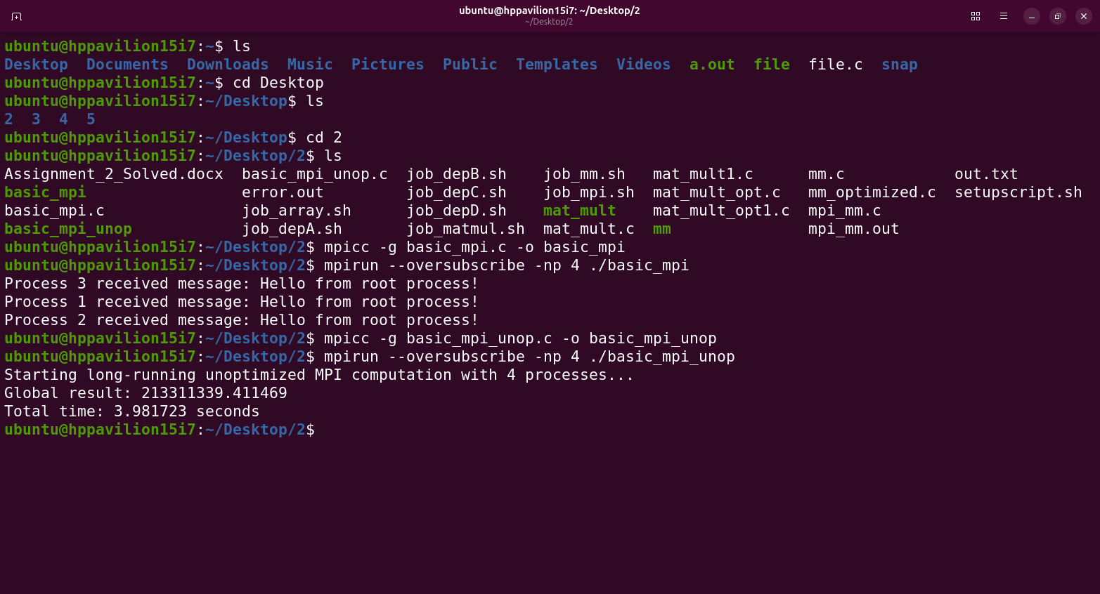

Part B — OpenMP matrix multiplication

1. Aim
To multiply matrices using OpenMP loop-level parallelism and measure execution time.

2. Procedure
- Initialize matrices A and B and initialize result matrix C to zero.
- Start the timer before the multiplication loop.
- Use #pragma omp parallel for to distribute iterations of the outer loop among threads.
- For each output element C[i][j], compute the dot product of row i of A and column j of B.
- Stop the timer and print elapsed time.
- Compile with OpenMP enabled and run with a chosen thread count.

3. Compile and run
Compile: gcc -O2 -fopenmp mm.c -o mm
Run with 4 threads: OMP_NUM_THREADS=4 ./mm
The supplied job_mm.sh uses OMP_NUM_THREADS=10 and runs the program through the SLURM scheduler.

4. Correctness note
The provided mm.c initializes every element of A and B to 1. Therefore, for a SIZE × SIZE multiplication, each element of C should equal SIZE (4000 in the supplied code). The program prints elapsed time rather than the full result matrix.
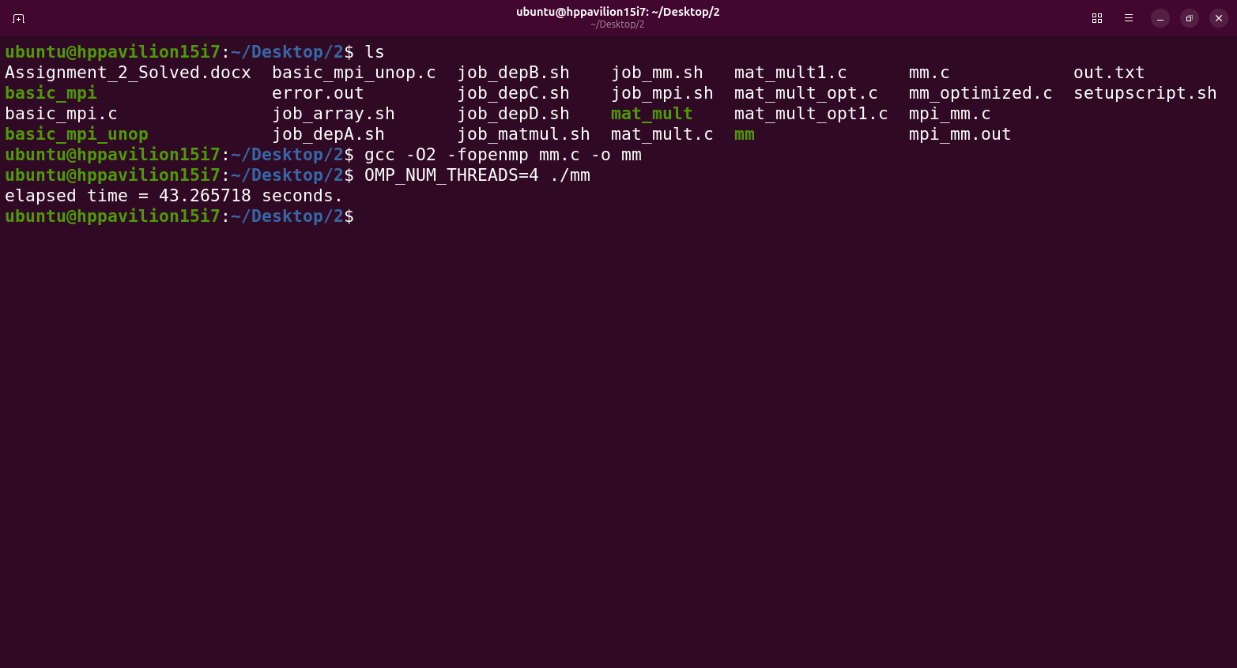

Part C — OpenMP scheduling and loop collapse
The files mat_mult.c, mat_mult_opt.c, mat_mult1.c and mat_mult_opt1.c demonstrate variations in OpenMP scheduling. The code compares dynamic scheduling with static scheduling and, in some versions, uses collapse(2) to parallelize the combined iteration space of the two outer loops.

Key differences
Feature | Meaning | Typical use
schedule(static) | Iterations are divided into chunks before execution. | Low scheduling overhead when work per iteration is similar.
Schedule(dynamic) | Threads request additional chunks as they finish. | Can help when iteration workloads vary.
Collapse(2) | Combines two nested loops into one parallel iteration space. | Can expose more parallel work when the outer loop alone has too few iterations.
Private(I,j,k) | Each thread gets its own copy of loop variables. | Avoids sharing loop-index state between threads.

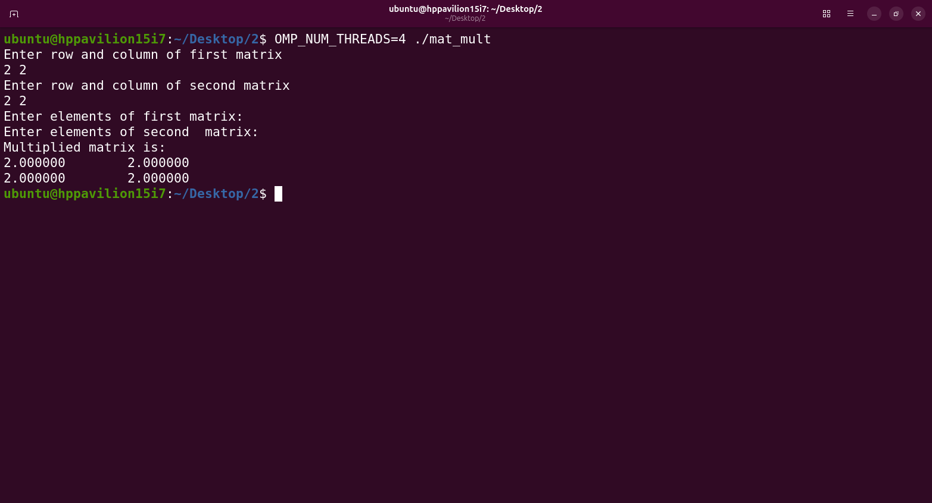
Part D — MPI distributed matrix multiplication

1. Aim
To divide matrix multiplication work across MPI processes and collect partial results at a master process.

2. Step-by-step procedure
- Initialize MPI and obtain each process's rank and the total number of processes.
- Designate rank 0 as the master and all other ranks as workers.
- The master initializes matrices A and B.
- The master divides rows of A among workers, sending each worker its row offset, row count, assigned rows, and matrix B.
- Each worker computes its assigned rows of the result matrix C.
- Workers send the offset, row count, and partial result back to the master.
- The master receives the partial results and reconstructs the complete result matrix.
- Finalize MPI.

3. Compile and run
Compile: mpicc mpi_mm.c -o mpi_mm
Run: mpirun -np 4 ./mpi_mm
The supplied job_mpi.sh uses a SLURM batch job and invokes the program with two MPI processes under the VTune hotspot collector.

4. Important code review note
In mpi_mm.c, the variable rc is used in MPI_Abort() before it is initialized in the early-exit branch. A safer version should call MPI_Abort(MPI_COMM_WORLD, 1). Also ensure that the MPI datatype matches the data type being sent; the arrays are double, so MPI_DOUBLE is appropriate.
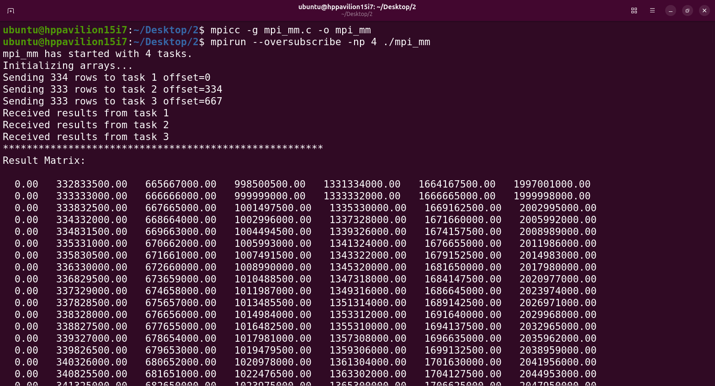
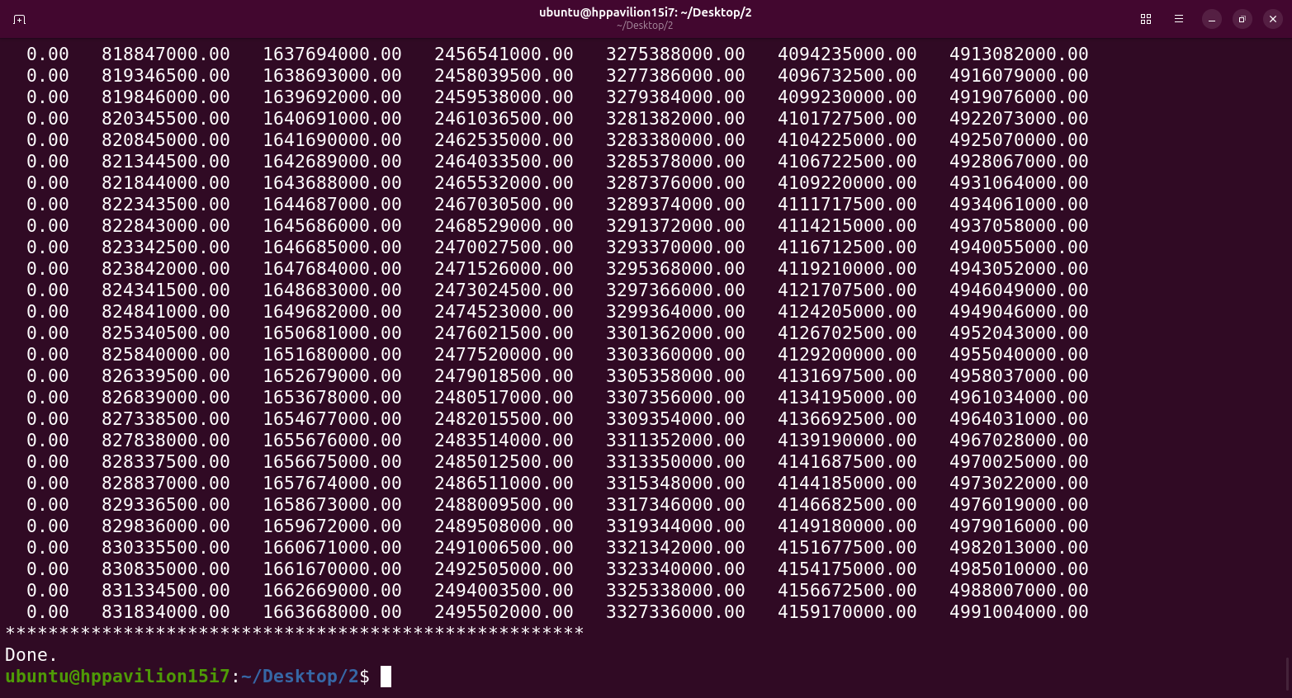

Part E — SLURM job scripts
The .sh files submit programs to a cluster scheduler. The directives beginning with #SBATCH configure job resources.
- #SBATCH -J sets the job name.
- #SBATCH -N or --nodes sets the number of compute nodes.
- #SBATCH --ntasks-per-node sets the number of tasks per node.
- #SBATCH --partition selects the cluster partition.
- #SBATCH --output and --error set output and error log files.
- #SBATCH --time sets the wall-clock time limit.
- Submit a job with sbatch job_mm.sh or sbatch job_mpi.sh, where the cluster environment and required compiler modules are configured.

